Automatic Solar Panel Tracker with Light Alert System
An ESP32-Based Embedded System for Solar Energy Optimization
Team Members: Nithisha S.K, Santhiya K

Brainstorming Report
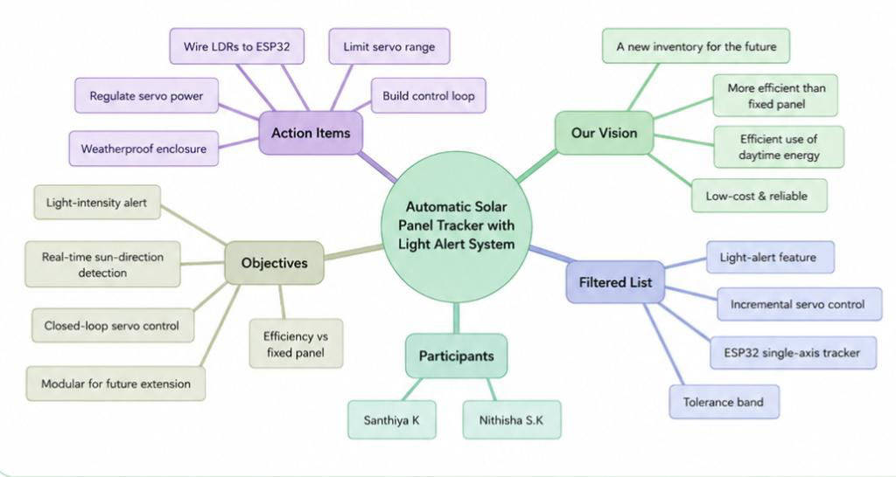

Idea Prioritization Matrix
The approaches reviewed in Section 1 were plotted on an impact-versus-effort grid to decide what belongs in the core build versus what is set aside.
Quick Wins (High Impact, Low Effort)  - Two-LDR differential sensing, single-axis (chosen)  - Single servo actuation with incremental movement  - Tolerance band to prevent servo oscillation  - Light-alert feature (reuses existing LDR data) | Major Projects (High Impact, High Effort)  - Dual-axis tracking (future extension)  - Cloud-based data logging / IoT remote monitoring (future extension)
Fill-ins (Low Impact, Low Effort)  • Fixed-mount panel (baseline reference only, for efficiency comparison) | Reconsider (Low Impact, High Effort)  • Mobile application integration (needs cloud/connectivity infrastructure not yet built)

Empathy Map
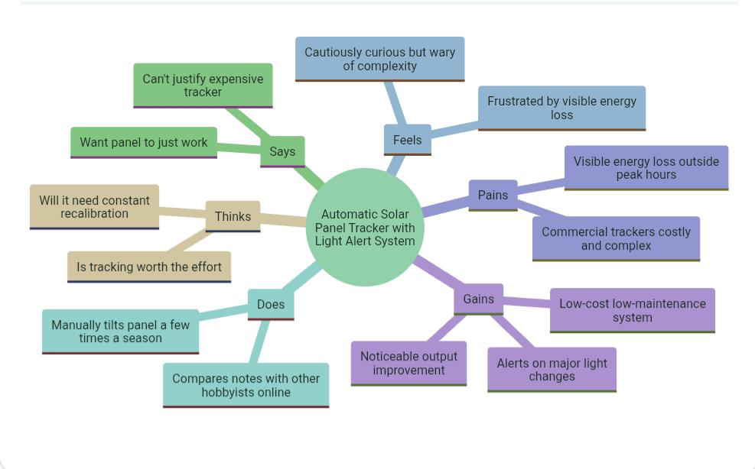

Proposed Solution

Problem Statement
Fixed-mount solar panels lose significant energy across the day because their tilt cannot follow the sun's changing angle, and existing tracking hardware capable of correcting this is too costly and complex for student or small-scale use.

Proposed Solution
An ESP32-based single-axis tracker that uses two LDR sensors to sense sunlight direction and a servo motor to reorient the panel, with a tolerance band for stability and a light-alert feature, delivering the core efficiency benefit of complex trackers at low cost and complexity.

How It Works
- Two LDRs mounted on either side of the panel continuously report analog light-intensity values to the ESP32.
- The firmware compares the two readings; if the difference exceeds the tolerance threshold, it commands the servo to rotate toward the brighter side.
- If the difference is within tolerance, the servo holds position — avoiding jitter under near-equal or rapidly fluctuating light.
- The same LDR data feeds a light-alert check that flags sudden, significant brightness changes (e.g., sunrise, sunset, heavy cloud cover).
- The cycle (sense → compare → actuate) repeats continuously, so the panel tracks the sun's motion throughout the day without manual input.

Why This Approach
It captures the core efficiency benefit reported across the reviewed literature — every tracking implementation outperformed a fixed panel — while keeping component count, cost, and firmware complexity low enough for a small student team to design, build, and calibrate within the project timeline. It also leaves a clear, modular path to dual-axis tracking and IOT-based monitoring as future extensions.

Functional Requirements
ID | Requirement
FR-1 | The system shall continuously read analog light-intensity values from two LDR sensors mounted on opposite sides of the panel.
FR-2 | The system shall compute the difference between the two LDR readings at a regular sampling interval.
FR-3 | The system shall rotate the servo motor toward the side with higher light intensity when the difference exceeds a configurable tolerance threshold.
FR-4 | The system shall hold the servo position (no movement) when the LDR difference is within the tolerance band.
FR-5 | The system shall constrain servo rotation within a safe mechanical range (minimum and maximum angle limits).
FR-6 | The system shall monitor ambient brightness and trigger a light-alert output when brightness changes beyond a defined threshold.
FR-7 | The system shall run its sense-compare-actuate cycle continuously and autonomously without manual intervention.
FR-8 | The system shall allow LDR and servo threshold values to be recalibrated via the Arduino IDE / firmware constants.

Non-Functional Requirements
Quality Attribute | Requirement
Performance | The control loop (sense → compare → actuate) shall complete within a short cycle time so the panel responds promptly to changing light without visibly hunting.
Reliability | The system shall operate continuously across a full day of sunlight variation, including intermittent cloud cover, without erratic servo behaviour.
Cost | Total component cost shall remain low enough for student/hobbyist replication, using only the ESP32, two LDR sensors, and one servo motor.
Power efficiency | The system's own power draw (ESP32 + servo) shall remain small relative to the energy gain it produces from improved tracking.
Usability | Calibration (tolerance band, alert threshold) shall be adjustable through simple, wellcommented firmware constants, not a rebuild of the code.

Quality Attribute | Requirement
Maintainability | The codebase shall be modular (sensing, control, actuation, alert as separate logical blocks) to support future extension to dual-axis or IoT features.
Durability | The mechanical mount and wiring shall tolerate normal outdoor exposure (basic weatherproofing) for the duration of testing.
Safety | Servo movement shall be range-limited to prevent mechanical strain on the panel mount or wiring at the extremes of travel.

Project Planning (Timeline)
The timeline below follows the official phase schedule: registration through 24 July, Phase 1–5 running from 25 July to 10 September, final submission and presentation preparation from 11–14 September, and the Grand Finale live demonstration on Engineers' Day, 15 September.
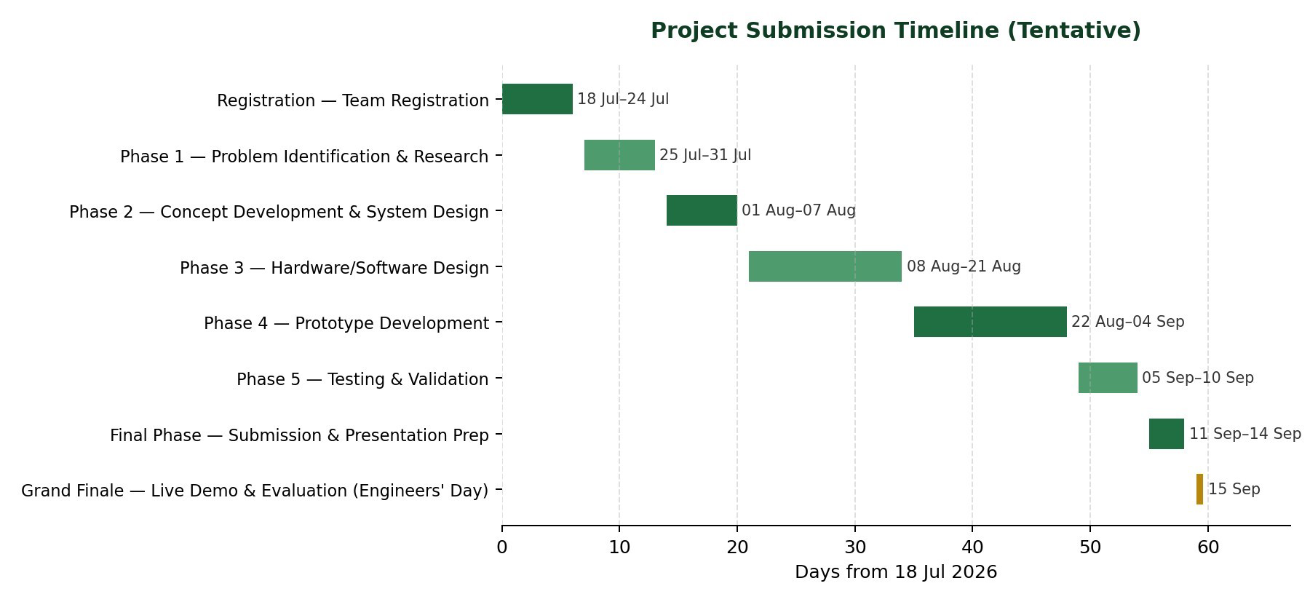

Risk Analysis
Key risks identified for the build, testing, and deployment phases, with likelihood, impact, and planned mitigation.
Risk | Likelihood | Impact | Mitigation
LDR readings fluctuate under partial cloud cover, causing servo hunting | Medium | Medium | Mitigated by the calibrated tolerance band; further smoothing via averaged/rolling sensor readings if needed.
Servo motor wear or mechanical backlash over repeated cycles | Low | Medium | Limit unnecessary movement via tolerance band;  use interval-based rather than per-sample actuation if wear is observed.
ESP32 or servo power instability under combined load | Low | High | Use a separate regulated supply for the servo rather than drawing directly off the ESP32's 5V/3.3V rail.
Outdoor exposure damages wiring or electronics (moisture, heat) | Medium | High | Basic enclosure/weatherproofing for the ESP32 and connections; route wiring to avoid pooling water.
Calibration drifts across seasons/latitude or installation angle | Medium | Low | Document calibration procedure clearly so thresholds can be re-tuned; keep constants easily editable.
Project timeline slippage  during integration/testing phase | Medium | Medium | Buffer time built into weeks 8–9 of the plan for calibration refinement and bug fixing.

Risk | Likelihood | Impact | Mitigation
Scope creep toward dual axis/IoT features before core system is stable | Medium | Medium | Extensions explicitly deferred to future scope; core single-axis system treated as the definition of done.

